The 13th Annual

Justice and Hope
Domestic Violence Conference
April 18, 2013

7:30 – 8:30 am REGISTRATION/COFFEE

8:30 – 8:45 am WELCOME Loowit Room

Opening comments Jeane Conrad, PeaceHealth Director of Patient Support and Community Services
Housekeeping and Introductions - Chere Weiss, Conference Coordinator

8:45 – 11:45 KEYNOTE PRESENTATION

Beyond the Obvious - A Community Response to Domestic Violence
Mark Wynn, Prevention Training and Consultant
. We will consider the difficult cases of dual-assault. This issue has broad implications beyond law enforcement and court cases; the content will be pertinent for victim’s advocates, perpetrator treatment providers, early childhood specialists, etc. This information will help us define and understand the issues of probable cause including, self-defense, interpretation of injuries and dominant/primary aggressor as well as define strategies to reduce the inappropriate dual arrests that frequently occur at the scene of domestic violence crimes.

10:00 – 10:15 Break

10:15 – 11:45 Keynote Continues

11:45 – 12:30 Lunch Buffet is served. Raffle and Announcements

12:30- 1:30 GENERAL ASSEMBLY Loowit Room

Finding and Helping the “Hidden Victims” – Responding to Children at the Scene
Mark Wynn, continues
One of the most overlooked and forgotten victims of domestic violence are the “hidden” victim, the children. Participants will gain a deeper understanding of the obstacles in dealing with children including observing key behaviors, investigation tips and developing safety plans. These areas are imperative for a successful interview and intervention with children.

1:30-1:45 Break

1:45 – 2:45 BREAK OUT SESSION OPPORTUNITIES (Rooms to be announced)

#1 Domestic Violence Impact Panels – What are They? What do they do? How can we start one?
Clark County Prosecuting Attorney Office shares their program history and outcomes. Jennifer Nugent, D.V. Impact Panel Coordinator and Andrew Hamlin Domestic Unit Sergeant Vancouver Police Department.

#2 In Their Shoes: Teen Stories
Sarah Hancock, Assistant Director of the Emergency Support Shelter brings this interactive groundbreaking scenario to those who work or interact with teens. In Their Shoes: Teens and Dating Violence shows what dating is like for today’s teens – from their perspective. The parents of a teen murder victim from Stanwood High School funded the development of this training to invest in the lives of others and to turn their grief into action.

3:00 – 4:00 GENERAL ASSEMBLY Loowit Room

Human Trafficking: 101
Detective Megan Bruneau, Seattle Police Department/Washington Advisory Committee on Trafficking
Human trafficking is the use of force, fraud or coercion to compel a person into any form of labor against their will. The Washington Advisory Committee on Trafficking is a state task force working to combat human trafficking. Studies have shown that human trafficking is the second most profitable criminal enterprise in the world, following only the drug trade. Washington State is one of four major gateways to human trafficking including domestic servants (housekeepers or nannies), construction workers, agricultural workers, employees in small businesses such as restaurants or salons, large factories, commercial sex work, and massage parlors. Victims of human trafficking in the United States are entitled to protection and assistance, regardless of their immigration status.

4:15 – 4:45 Law Enforcement Awards and Refreshments

4:45 – 5:00 Grand Prize Drawing, Closing Remarks, Evaluations and Adjourn

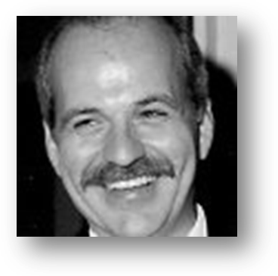
Keynote Speaker
Mark Wynn, Training Consultant
“Beyond the Obvious –
A Community Response to Domestic Violence”

Cowlitz County Regional Conference Center
1900 7th Ave., Longview, WA
www.kelsoha.org/Justice and Hope

For driving directions:
http://www.co.cowlitz.wa.us/expo/

Provider approval is pending by
California Board of Registered Nursing, #20128
offers 5.75 contact hours.
All participants are eligible to receive a certificate of attendance.
Clock hours available from OSPI for WA State K-12
Agenda and speakers subject to change.

The Justice and Hope Conference
is a collaborative effort hosted by:

PeaceHealth St. John Medical Center
The Emergency Support Shelter
Kelso Housing Authority
Longview Police Department and
St. James Family Center

