The Wichita Eagle
AUGUST 15, 2015

Officials: Violence level increasing for women seeking shelter from abusers
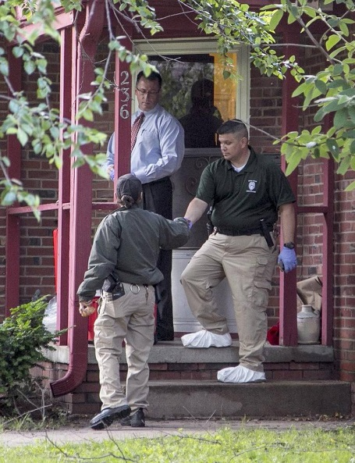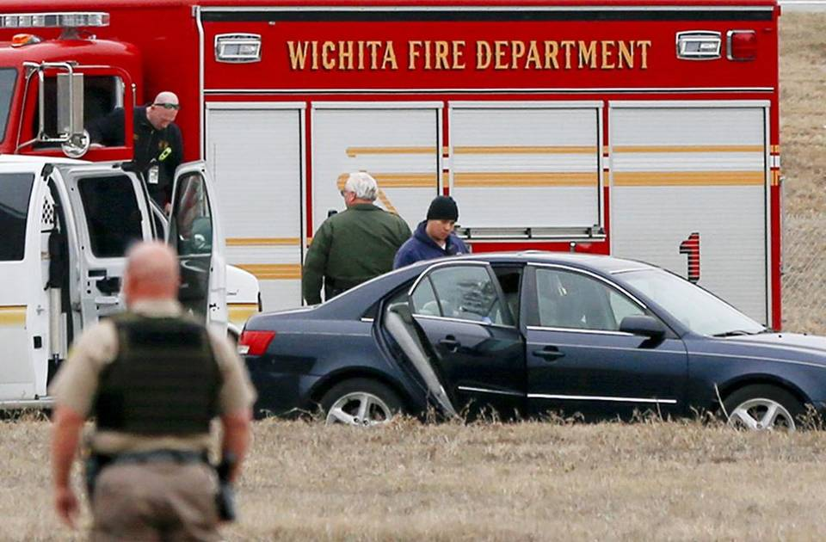

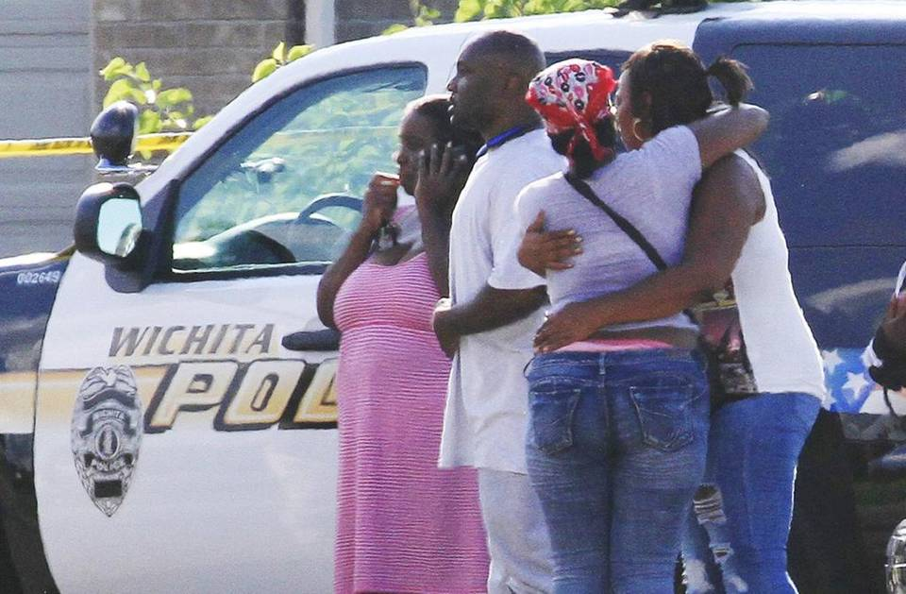
of 3
Police investigate the car in which the body of Sabryna Guerrero-Newman was found just west of Hydraulic and 19th on Jan. 30. She is one of six people killed in homicides tied to domestic violence in Wichita in 2015. Fernando Salazar File photo
BY STAN FINGER
The Wichita Eagle
Many Wichita residents may have been shocked when confrontations involving domestic violence resulted in three deaths less than two hours apart on Monday, but officials at local shelters for abused women were not among them.
Over the course of her seven years as executive director of Harbor House, Joyce Mahoney said, “the intensity of the violence (women are facing) has increased dramatically.”
“Seven years ago, we basically took anybody who had been a victim of domestic violence of some sort over the last six months,” Mahoney said. Over time, however, “we’ve had to limit the people who can come in to those that are in imminent danger from their abuser.
“‘Has he threatened to kill you before? Has he tried to strangle you? Does he have a gun?’ We just have to take the worst of the worst (cases) here now.”
Six of Wichita’s 17 homicides so far in 2015 have been connected to domestic violence, police say, including two on Monday. That compares with three all of last year and seven in 2012, according to data provided by police officials.
It’s almost double the average number of domestic violence homicides over the previous 11 years.
“We know why people kill one another in domestic violence cases – as a last act of control,” said Mark Wynn, a former Sedgwick County sheriff’s deputy who has become a nationally known speaker on domestic violence. “This is a crime of power and control.”
Among the homicides classified by police as domestic violence are Sabryna Guerrero-Newman, who was found dead inside a car in January after being carried out of a house on North Hydraulic; her boyfriend has been arrested. Also Tanya Tandoc, the Wichita restaurant owner who was killed in June by Curtis Mitchell, who lived in her house. Mitchell pleaded guilty to first-degree murder.
The escalation in violence is not just a Wichita phenomenon, said Joyce Grover, executive director of Kansas Coalition Against Sexual and Domestic Violence.
“The level of dangerousness … has increased over the last few years,” Grover said. “I hear that pretty much from every program across the state.”
When someone comes to a shelter now, it’s not simply with physical and emotional abuse, Grover said. It’s women who have been strangled multiple times or have even suffered gunshot wounds.
While this development is disturbing, shelter officials say, it’s also a good sign. Years ago, such violent abuse went unreported until someone died.
“I don’t think in just seven years all these people have turned into monsters,” Mahoney said. “I just think more women realize they can get help now.”

Getting help
The challenge, Mahoney and others said, is making sure that help is available when someone needs it.
Harbor House has 40 rooms for victims of domestic violence, and in July alone the shelter had to turn away 140 women and children because it was full. The shelter has had to turn away an average of 105 women and children a month so far in 2015.
The YWCA Women’s Crisis Center has also seen an increase in need, executive director Kim Chronister said. The 22-bed shelter had to turn away 550 women and children because of a lack of space in 2013. Last year, that number grew to 680.
“When they’re calling and asking for help and asking to get out and we can’t take them into emergency shelter – oh my gosh, that’s so hard,” Chronister said. “But we try to do the best we can with our resources.
“We try to do anything or everything we can to help them.”
If space isn’t available at the shelter, Chronister said, the woman may be given a gasoline card or a hotel room so she can get away from her abuser.

Greatest danger
Shelter officials say an abused woman is never in more danger than when she is about to leave the relationship. Grover said the first deadly shooting incident Monday in Wichita was a reflection of that.
Dorce Pittman, 42, went to a house in the 1400 block of North Lorraine shortly before 3:30 p.m. to confront a woman who had fled after breaking up with him on Saturday, police have said. She refused to come out of the house and talk to him, so Pittman fired a shot at the house and took off running east on 14th Street.
Moments later, witnesses told police, several shots were fired. One struck Pittman in the head. He collapsed in the street and died at the scene.
Police still have no suspects in the case. Until they know who killed Pittman, Lt. Todd Ojile said, police officials won’t know whether to classify his death as a domestic violence homicide.
But Grover said she has no doubt the incident has its roots in domestic violence.
“It was about her leaving,” Grover said. “She had already left. She was in danger. Had she walked out (of the house on Lorraine), she might have been shot right there.”
About 90 minutes later, a 41-year-old woman called 911 to report she had heard a gunshot in her house and had barricaded herself in her bedroom for safety. By the time officers arrived, 28-year-old Jordan Bobo had killed his girlfriend, 21-year-old Alaysia Sellers, shot her 20-year-old sister several times and then committed suicide.
Three out of four domestic violence homicides occur as the victims are attempting to break away, said Wynn, the former sheriff’s deputy. That’s why it’s so important for communities to have resources available when victims are ready to take that step.
Wichita shines in that regard, Wynn said.
“You’ve got a strong shelter program in Wichita,” he said.
Along with shelters for women just escaping an abusive environment, he said, the city has transitional housing for women and children as they build a life independent of the abuser. Far too many cities still have large gaps in their systems.

‘It’s so complicated’
Studies have shown that 1 in 4 women and 1 in 7 men are victims of domestic violence, Chronister said. Domestic violence crosses all demographic categories and income levels.
Victims stay with or return to abusive partners, shelter officials say, because they don’t think they can get the help they need.
“It’s so complicated, and the complications are very individualized,” Chronister said. “If you have a child with the person that is abusing you, it is even more difficult. It becomes the tool to try to get her to come back.”
The Women’s Crisis Center has an emergency crisis line – 316-267-7233 – that victims can call to get advice and help, Chronister said.
An important part of the process, she said, is what officials call “safety planning.” That includes packing a small bag and “having it ready to go at any time,” Chronister said.
The planning includes figuring out where they can go when they leave and having those answers and the “go bag” ready “before the violence gets so bad they have to call 911,” she said.
Others may view a person leaving an abusive situation as an event, Wynn said, but it’s a process.
“Victims have to look ahead,” Grover said. “‘If I leave this situation, am I going to lose my job? Where will the kids go to school?’
“They have to make all these decisions based on the future. It can feel like, it’s going to be worse if I leave and don’t have anyplace else to go.”
Reach Stan Finger at 316-268-6437 or sfinger@wichitaeagle.com. Follow him on Twitter: @StanFinger.
DOMESTIC VIOLENCE HOMICIDES IN WICHITA
2015: 6 - 2014: 3 - 2013: 1 - 2012: 7 - 2011: 7 - 2010: 5
2009: 4 - 2008: 1 - 2007: 5 - 2006: 2 - 2005: 3 - 2004: 5
Source: Wichita Police Department
Read more here: http://www.kansas.com/news/local/article31198808.html#storylink=cpy

